CD LAB-2 PRELIMINARY SCANNING APPLICATIONS

Name: Ketan Goud
Reg No: 220905260
Section: CSE D- D2
Roll No: 39

1. That takes a file as input and replaces blank spaces and tabs by single space and writes the output to a
file.
Code:
#include<stdio.h>
#include<stdlib.h>
int main()
{
FILE *fa, *fb;
int ca,cb;
fa=fopen("q1.c","r");
if(fa == NULL)
{
printf("Cannot open file\n");
exit(0);
}
fb = fopen("q1out.c","w");
ca = getc(fa);
while (ca != EOF)
{
if(ca == ' ')
{
while(ca == ' ')
{
ca = getc(fa);
}
putc(' ',fb);
}
else if(ca == '\t')
{
while(ca == '\t')
{
ca = getc(fa);
}
putc(' ',fb);
}
else
{
putc(ca,fb);
ca = getc(fa);
}
}
fclose(fa);
fclose(fb);
return 0;
}

Sample Input and Output:
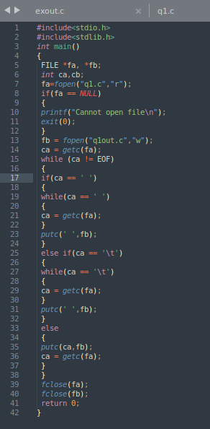

2. To discard preprocessor directives from the given input ‘C’ file.
Code:
#include<stdio.h>
#include<stdlib.h>
int main()
{
FILE *fa, *fb;
int ca,cb;
char line[1024];
fa=fopen("q2.c","r");
if(fa == NULL)
{
printf("Cannot open file\n");
exit(0);
}
fb = fopen("q2out.c","w");
while (fgets(line, sizeof(line),fa))
{
if(line[0]!='#')
fputs(line,fb);
}
fclose(fa);
fclose(fb);
return 0;
}

Sample Input and Output:
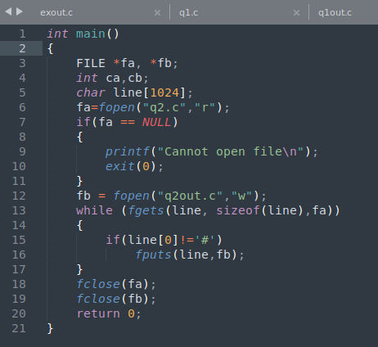

3. That takes C program as input, recognizes all the keywords and prints them in upper case.
Code:
#include<stdio.h>
#include<stdlib.h>
#include<string.h>
#include <ctype.h>
int check(char word[10])
{
return (strcmp(word,"else")==0 || strcmp(word, "int")==0 ||
strcmp(word,"while")==0 || strcmp(word,"if")==0 ||
strcmp(word,"return")==0 || strcmp(word,"char")==0);
}
void to_uppercase(char word[])
{
for (int i = 0; word[i] != '\0'; i++)
{
word[i] = toupper(word[i]);
}
}
int main()
{
FILE *fa, *fb;
int i,ca,cb;
char word[10];
fa=fopen("q3.c","r");
if(fa == NULL)
{
printf("Cannot open file\n");
exit(0);
}
fb = fopen("q3out.c","w");
ca = getc(fa);
while (ca != EOF)
{
if(ca >= 'a' && ca <= 'z')
{
i=0;
while(ca >= 'a' && ca <= 'z')
{
word[i]=ca;
ca = getc(fa);
i++;
}
word[i]='\0';
if(check(word))
{
to_uppercase(word);
fputs(word,fb);
putc('\n',fb);
}
}
else
{
ca = getc(fa);
}
}
fclose(fa);
fclose(fb);
return 0;
}

Sample Input and Output:
